***Robin Munro:***

***Obituaries***

[*Version*](https://perma.cc/B9E6-LSLN) *date: June 29, 2021*

***China Labour Bulletin***

<https://clb.org.hk/content/tribute-robin-munro>

*A tribute to Robin Munro*

*20 May 2021*

China Labour Bulletin is deeply saddened by the passing of our former deputy director and great friend, Robin Munro.

Robin set the gold standard for human rights research in China, and also took direct action to help countless people in China suffering from political persecution. At CLB, Robin not only ensured that our reporting on workers’ rights was of the highest quality, he also guided us into a position where we were able to provide lasting support to labour activists and the workers’ movement.

CLB Executive Director Han Dongfang paid tribute to his old friend and colleague:

“Robin worked tirelessly over the past two decades to provide legal assistance for tens of thousands of Chinese workers seeking justice through the court system. Many of them had suffered terrible work injuries, contracted occupational diseases, or were desperate to get the back pay owed for months, even years, of hard labour. Many workers faced imprisonment for defending their legal rights. These workers and their families should know that it was this Scotsman, Robin Munro, who helped them obtain justice.

“Even before joining CLB, Robin helped many Chinese dissidents, who might otherwise have died in prison, to gain their freedom. I was one of them.

“Robin was not only a colleague but a teacher and mentor who helped me fly higher, further and better. He was like an older brother who loved and cared about me. He was a member of my family and a caring and funny Scottish uncle to my children. We will all miss him dearly.”

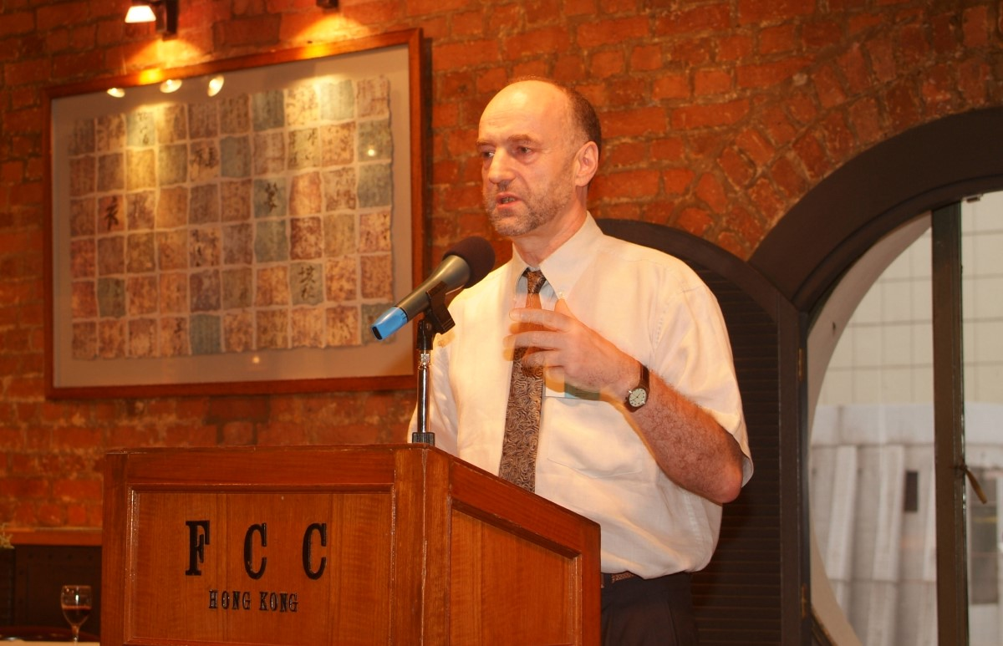

*Robin Munro introduces Han Dongfang at the 2005 Gleitsman International Activist Award ceremony in Hong Kong*

Robin's association with CLB dates back three decades to 1989. As a human rights activist monitoring the protests in Beijing, he was a regular visitor to the Beijing Workers’ Autonomous Federation encampment in Tiananmen Square, where Han was based at the time.

Han was arrested and contracted tuberculosis while in prison. Following his release from prison in 1991, Robin was instrumental in arranging medical treatment for Han in the United States. When Han settled in Hong Kong, Robin ensured that he had the support he needed to set up CLB and continue the struggle.

Throughout the 1990s, as China researcher for Human Rights Watch, Robin produced numerous ground-breaking reports on political repression and social injustice in China, most notably, the use of state psychiatric institutions in the crackdown on dissent. Robin developed this research in his PhD thesis, which was published in 2006 as *China’s Psychiatric Inquisition: Dissent, Psychiatry and the Law in Post-1949 China*.

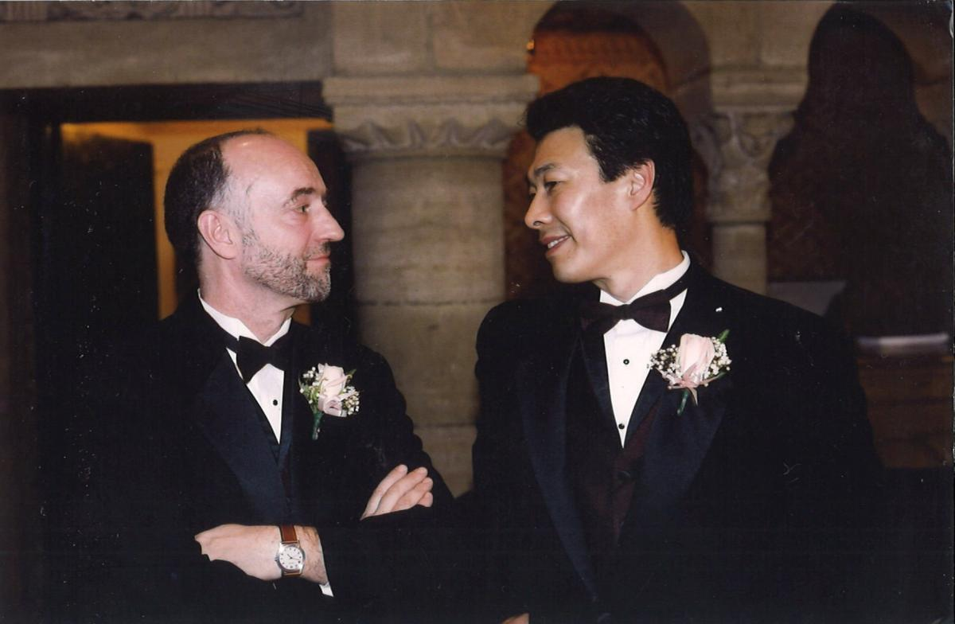

*Robin Munro and Han Dongfang in 2002.*

Robin stepped back from day-to-day work at CLB in 2011 but he was always close by, offering advice and unflagging support. As Executive Director of Friends of China Labour Bulletin, Robin helped ensure that CLB kept to our core mission and had a sound strategic plan for our future development.

Robin will be greatly missed by his friends and colleagues at CLB, and everyone who was touched by his fierce intelligence and dedication to the workers’ cause.

“Robin’s life mission was to help people and save lives. We will honour his legacy and continue the long journey we started 30 years ago.” — Han Dongfang.

***悼念罗宾・芒罗*** *Robin Munro****先生***

*2021年05月20日*

中国劳工通讯痛悉我们的挚友、前副主任罗宾・芒罗（Robin Munro）在2021年5月19日与世长辞。

罗宾先生是研究中国人权问题的权威，他身体力行帮助过无数中国政治犯。在参与中国劳工通讯的工作中，他不仅完成了大量有关工人权益的高质量报告，更引领我们制定长远支援工运人士和工人运动发展的方向。

中国劳工通讯负责人韩东方向他的老朋友和老同事致以哀悼：

“过去的二十多年，在数以千计的中国劳工需要法律为他们主持公道的时候，罗宾不知疲倦的为他们奔波、提供法律援助。其中有很多工人遭受严重工伤、罹患职业疾病、或者遭遇数月甚至数年的欠薪，困顿不堪。甚至有很多工人仅仅是为了维护自身权益而身陷牢狱之灾。是罗宾・芒罗先生，这个苏格兰人帮助他们讨回了公道。”

“在加入中国劳工通讯之前，罗宾先生一直都在拯救身陷牢狱之灾的中国政治犯，帮助他们重获自由，远离死亡的威胁。我本人便是其中一个。”

“罗宾对我来说不只是朋友，更是一个教导我飞的更高更远更好的导师。他像兄长一般照顾关爱我，他就是我家庭中的一员，是我孩子眼中爱他们的、有趣的苏格兰伯伯。我们会永远怀念他。”

罗宾与中国劳工通讯的渊源要追溯到三十多年前的1989年。他当时作为人权工作者，对北京的示威状况进行观察。他也经常探访天安门广场上北京工人自治联合会的营地，当时韩东方也身在其中。

韩东方被捕后，在狱中罹患肺结核。1991年韩东方甫一出狱，罗宾便促成了韩东方赴美治疗的行程。韩东方定居香港之后，罗宾支持韩东方成立中国劳工通讯以继续开展工人运动工作。

九十年代，罗宾作为人权观察研究员，针对中国的政治压迫和社会不平等现象，撰写一系列突破性的重要报告。尤其值得注意的是中国利用精神病机构作为打压异见者的手段。罗宾将此文进一步深化成他的博士论文，在2006年以《1949年后中国的精神审讯：异见、精神病学与法律》为题发表。

2011年，罗宾退出中国劳工通讯的日常工作，但他从未离开，他担任中国劳工通讯之友执行主任，一直为中国劳工通讯的核心使命而努力，更为我们制定未来发展良策指引方向。

作为罗宾的朋友、同事，我们会永远怀念罗宾，他的睿智和对工人的热诚深深感动着我们。

“罗宾一生都致力于帮助他人和拯救生命。我们将荣幸地继承他持续了30多年的奋斗遗产。”— 韩东方



***Donald Clarke (The China Collection blog)***

<https://perma.cc/GQN5-CDDJ>

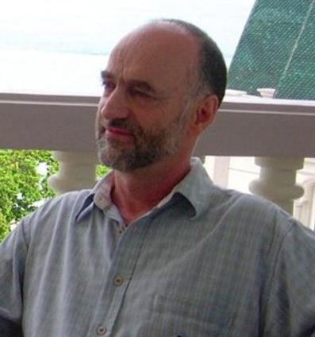

*Robin Munro, 1952-2021*

*May 19, 2021*

It breaks my heart to announce the passing on May 19th in Taiwan of my dear friend of over 40 years, Robin Munro. I am posting this mini-obituary (a full one will follow in due course) here because of Robin’s contributions to China and China studies.

Robin was a passionate and committed human rights activist, but crucially he was also a meticulous and gifted scholar. Some people work on the individual level, some on the systemic level. Robin did both. Many individuals owe to Robin’s unstinting efforts on their behalf the fact that they are not in jail in China (or worse). Painting on a larger canvas, Robin identified and wrote pathbreaking reports on key human rights issues in China: among others, [psychiatric abuse](https://perma.cc/P3DD-54ZQ), [abuses in orphanages](https://perma.cc/5CB9-FBHL), and [organ harvesting](https://perma.cc/QE5S-WPM2). He was there first. And his reports were meticulously and irrefutably documented with Chinese sources. (Check out [this colloquy with his critics](https://lawprofessors.typepad.com/china_law_prof_blog/2007/01/new_book_chinas.html) in which — perhaps I am biased — he pretty clearly comes out on top.)

I think that a key part of Robin’s success as an activist was his sense of responsibility, as a scholar, to the truth as supported by evidence. Despite his passion — who could make a career out of human rights activism without passion? — he never exaggerated. [Here he is writing](https://perma.cc/84HT-XPD2) that the June 4th massacre (which he personally witnessed) was indeed a massacre, but was not a massacre of students and did not take place in Tiananmen Square, and why that is significant. This is why when he told journalists or government officials that something was happening, they could have confidence that it was the truth.

In an era when the term “Renaissance man” is overused — I once heard David Byrne described as such pretty much because not only did he write songs, but he also sang songs, produced songs, and recorded songs — I think Robin truly fit the description. In addition to being both an activist and a scholar (earning a Ph.D. at the School of Oriental & African Studies, for those who want an official seal of approval), he was a tremendously talented guitarist, largely in the realm of folk music, and a keen student of music history and lover of all kinds of music, from Josquin des Prez to Schoenberg and beyond. He spent many happy hours tinkering with his audio system at home, eagerly telling me of the latest upgrade. It was indeed a revelation to me when I first heard the system he had set up in his home in Taiwan, which could make even the [Barney song](https://youtu.be/KmpMO2dJQ6Q) sound exquisite, and it’s because of Robin that I now listen mostly to vinyl records through a vacuum tube amplifier. He was also skilled with his hands, from rebuilding guitars to outdoor projects.

I should not leave unsaid that Robin was a devoted husband to his equally devoted wife, Pao-lien, a talented writer. As many others have told me and as I know myself, visiting them was always a pleasure.

In the few hours since I posted the news of Robin’s passing on Twitter and within the China studies community, I have seen many tributes from those who worked with him, sought his knowledge as journalists, or learned from him as junior colleagues. What really comes through in all these messages is the sense of his integrity and his decency. I don’t know if I would describe Robin as an especially charismatic character; I don’t know what you would think if you had only a passing acquaintance, and he certainly did not shy away from an argument (which I am in no position to consider a character flaw). But everyone who got to know him — at least, everyone who shared his basic values — came to appreciate that, in Shakespeare’s words, “His life was gentle, and the elements mixed so well in him that Nature might stand up and say to all the world, ‘This was a man.’”



***John Chow (Doctorjohn Cheaptubeaudio blog)***

[*https://perma.cc/JDU4-78UH*](https://perma.cc/JDU4-78UH)

*In Memory of Robin*

**[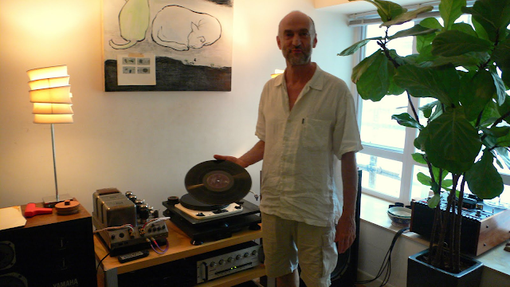](https://lh3.googleusercontent.com/-t6Q2q6OU6cA/YMi7ijhzwvI/AAAAAAAAFnY/Q8D0zeVqJQAnXkth5sr2pAMQ_xPBH8yKwCLcBGAsYHQ/image.png)**

*In Memory of Robin (The Scot)*

*Hi-Fi Basics XIII: The Preciousness of a Fellow Traveler*

Regular readers of this blog will be familiar with my friend Robin (not Hood, but a proud Scot), whose audio endeavors in Hong Kong (and later Taiwan) I have chronicled as much as I could have. Now, the sad news: he had passed away in Taipei some weeks ago.

I mentioned before that Robin had harbored a chronic illness for the last decade. As one would have expected of him, he not only had weathered it well, but lived a very full life. He died from an unrelated and unexpected illness. I had also never mentioned Robin's professions, and am not going to do so now. Suffice to say he devoted most of his life to helping others, mostly people he had never met. A noble endeavor.

The mid eighties were my halcyon days in New York. Those were the days when artists from all the Chinese worlds started to converge in NYC, and I count myself lucky to have been part of the crowd (as you know, doctors are frequently negatively portrayed by artists, certainly in music, as in *Wozzeck*). Believe it or not, even in that age, when excessive and ugly financial practices started to dominate the world and set the world on the path to the unprecedented global inequity of today, there were plenty of innocence to be had, more so than today, I'd say.

I actually knew Robin's wife before I met Robin. I really did not see him that many times in NYC, but I remember for some reason his looks one evening on the street. I can only say he was on fire. I don't remember why; maybe he had just met his future wife? But that look has stayed in my mind all these years. Robin was a man of passion, and not afraid to show it.

Our paths converged again when the couple relocated to HK, but I didn't see them often at all, especially since they were in and out, had busy professional lives, and lived on Lamma Island, far away from me. It was not until they moved to Central that we met more often, especially since Robin by this time had taken up audio.

This late phase, where we saw each other more often (but not often enough) started when I paid them a visit in the Central flat. Then Robin came to my place and was stricken by the Yamaha NS-1000, which he instantly knew was what he wanted. It transformed his entire audio journey and he then went up to the FX-3, which I'd never have heard otherwise. It was what he gave me in turn. Then, he restored my Garrard 301 and went on to R2R. If you look at the timeline in my blog, for the past decade I had made few home visits but, for this article, I revisited the posts and am shocked by how many of my yumcha friends I had taken to experience his setup. Indeed, with Robin, I probably did some of my best writing, and that is for a good reason. For this, below:

*The Preciousness of a Fellow Traveler*

When I chewed on the news of Robin's passing, in no time it dawned on me how much he stood out for his sincerity and lack of pretense, rare among audiophiles. He became an audiophile because he loved music and wanted more fidelity, which is me too, despite my excesses.

Then, it occurred to me that I should write an (Hi-Fi Basics) article on the importance (or luck) to have a fellow companion on an audio journey. Perhaps due to a past life of an academic (albeit somewhat forced upon me) I tend to be methodical, and inclusive, so in the end I often become long-winded. So, I started to draft a long article on how important a fellow traveler can be in audio. What I mean is the presence of meaningful exchanges, to-and-fro. However, true exchanges like this are still regrettably rare in audio, as most focus more on the hardware than the meaning of music (which a proper vintage mono setup can probably convey as much as modern “state-of-the-art”). Accordingly, I planned the article and wrote quite a bit before I realize that, in re-visiting what I wrote about Robin, I had already conveyed most of my feelings.

Even if the methodical in me often re-synthesized an old article or idea into a new one, what I wrote about Robin and I, together on a journey, cannot be superseded. Once I re-read everything I had written about our encounters, I knew that this series is the perfect ode to Robin. It has a coherence of its own, rare and precious. Plus, I am very glad to have shot a short video footage of him, which to this date I have not done for anyone else. It is all for the glory of music. SO:

If you haven't read these, they encapsulate the philosophy of this blog. I am also glad that my good friend icefox, very discriminating, shared in our joy together. Click and read, and I am sure you will not be disappointed:

[https://cheaptubeaudio.blogspot.com/search?q=robin](https://www.blogger.com/)

[17 January, 2009 Home Visit:: Robin's Nest](https://cheaptubeaudio.blogspot.com/2009/01/home-visit-robins-nest.html)

[15 October, 2009 Part II. From Beryllium to Beryllium](https://cheaptubeaudio.blogspot.com/2009/10/yumcha-diaries-10-10-09.html)

[07 September, 2010 04-09-10 Return to Robin's Nest](https://cheaptubeaudio.blogspot.com/2010/09/yumcha-diaries-04-09-10-and-28-08-10.html)

[27 January, 2011 Talk Vinyl: Restoration of Garrard 301 Part II](https://cheaptubeaudio.blogspot.com/2011/01/talk-vinyl-restoration-of-garrad-301_27.html)

[03 February, 2011 Talk Vinyl: Restoration of Garrard 301 Part III](https://cheaptubeaudio.blogspot.com/2011/02/talk-vinyl-restoration-of-garrad-301.html)

[09 February, 2011 Talk R2R: How to Describe the Sound of R2R?](https://cheaptubeaudio.blogspot.com/2011/02/talk-r2r-how-to-describe-sound-of-r2r.html)

[26 June, 2011 Audiophiles in Illness - Music as Therapy](https://cheaptubeaudio.blogspot.com/2011/06/audiophiles-in-illness-music-as-therapy.html)

[27 August, 2011 Welcome back Robin, we'll be missing you!](https://cheaptubeaudio.blogspot.com/2011/08/welcome-back-robin-well-be-missing-you.html)

[30 June, 2012 Letter from Robin in Taipei](https://cheaptubeaudio.blogspot.com/2012/06/letter-from-robin-in-taipei-editor-as.html)

[29 August, 2016 Home Visit: My Dear Old Friend Robin the Scot](https://cheaptubeaudio.blogspot.com/2016/08/robin-taipei-un-tweaking-townsend.html)

[29 October, 2017 Letter from Taipei: Robin's New Toys](https://cheaptubeaudio.blogspot.com/2017/10/letter-from-taipei-robins-new-toys-home.html)



***Human Rights Watch***

<https://perma.cc/84TB-NTLS>

Human Rights Watch mourns the death of Robin Munro, who joined Human Rights Watch in 1989 as China researcher and Hong Kong office director. His eyewitness reporting on the 1989 crackdown on pro-democracy protesters at Tiananmen Square in Beijing helped the world understand and respond to the Chinese government’s violent repression.

Munro passed away in Taiwan on May 19, 2021.

While working at Human Rights Watch from 1989-1998, Munro did pathbreaking research on China’s psychiatric abuse of political prisoners, abuses in orphanages, and organ harvesting of convicts. He also broke new ground reporting on Inner Mongolia, the laogai (“reform through labor”) detention system in Xinjiang, and repression of Catholics in Hebei province. While researching the first major report on China’s Three Gorges Dam, Munro unearthed a government coverup of the collapse of a different dam several years earlier through malfeasance and shoddy construction.

“Robin Munro was a powerful advocate for human rights in China who played a pivotal role in helping dozens of dissidents from China resettle abroad and pursue their activism,” said [Kenneth Roth](https://www.hrw.org/about/people/kenneth-roth), executive director of Human Rights Watch. “He was a colleague whose passion for research, the truth, and justice inspired us all.”

He was the lead researcher on groundbreaking reports, including *Detained in China and Tibet: A Directory of Political and Religious Prisoners* (1994); *Death by Default: A Policy of Fatal Neglect in China’s State Orphanages* (1996); and *Dangerous Minds: Political Psychiatry in China Today and its Origins in the Mao Era* (2002).

Munro, a prolific writer, and George Black, in 1993, co-authored *Black Hands of Beijing: Lives of Defiance in China's Democracy Movement*, which traced the lives of three leading Tiananmen activists to explain the genesis of pro-democracy movements.

After leaving Human Rights Watch, Munro studied at the University of London’s School of African and Oriental Studies (SOAS), where he continued his research on abuses of psychiatry and earned a doctorate. Throughout his career as an activist, journalist, and scholar, Munro was known for his meticulous research, repeatedly fact-checking and re-interviewing sources. After SOAS, Munro joined the Hong Kong-based China Labour Bulletin, founded by Han Dongfang, one of the Tiananmen leaders Munro helped escape to freedom. He stepped down from the organization in 2011.

Munro inspired and mentored subsequent generations of scholars and activists, giving them time, attention, and advice. He read drafts of manuscripts and journal articles, debated political trends inside China, offered advice on advocacy strategies, and always had recommendations about great music and stereo equipment (old-style valve amplifiers were, in his view, *de rigueur*).

Munro, who was from Scotland, always proudly listed among his professional experience his stint as an Edinburgh bus driver. He liked to joke that learning Chinese might mean finally being understood in at least one language. He always brought warmth and support to discussions, encouraging people whose human rights were already secure to deploy those rights in service of helping others.

“For Human Rights Watch and especially its China team, Robin was a hero, a role model, and an extraordinary friend,” said [Sophie Richardson](https://www.hrw.org/about/people/sophie-richardson), China director at Human Rights Watch. “He will be deeply missed as a scholar and an activist, but his legacy will live on in our work, and in the lives of so many he kept out of China’s prisons and supported at critical moments.”

Human Rights Watch sends condolences to Robin’s longtime partner, the writer Pao-lien Huang.



***School of Oriental & African Studies***

<https://perma.cc/3RWS-UE7Y>

*Robin Munro, 1952-2021*

Robin Munro, human rights scholar and activist, and the author of pathbreaking studies of human rights abuses in China, passed away peacefully of complications from illness on May 19, 2021.

**I**

Robin was born in London on June 1, 1952, a brother to 4-year-old Sandra. He had a peripatetic childhood. His father Sandy was at the time a lecturer at King’s College London in physiology. When Sandy decided to study medicine, he and Robin’s mother, Ailie, sent Robin and Sandra in 1955 to live in Aberdeen for a year with their paternal grandparents and other extended family members, so that Sandy could better focus on his studies. It was a difficult time for both Robin and Sandra, despite the warm care they received, and was the beginning of a special closeness and love between them that lasted all of Robin’s life.

After his return from Aberdeen, Robin lived in London until 1958, when his father, who had always wanted to return to Scotland, took up a lectureship at the Veterinarian School at Glasgow University. In Glasgow, Robin went to Hillhead High School, where he flourished academically and personally. In 1962, however, his parents split up and his father moved to Edinburgh. After about a year, Robin asked if he could live with his father because he felt sorry for him and wished to support him, and with the consent of his mother went off to Edinburgh. This move, however, had an unhappy outcome; his father was in an emotionally unstable state and Robin was under unbearable pressure. Nevertheless, he managed to do well academically at George Watson’s College and got the necessary qualifications to enter Edinburgh University in 1969.

Like many young people in that era, Robin tried a number of things. His first chosen subject at university was psychology, but neither the subject nor university life appealed to him and he left before the end of the year. He later returned for a second year to study a different subject, but—fortunately for the human rights community—still felt he had made the wrong choice. At some point during his time in Edinburgh, he worked as a bus driver, a job he was proud of and always put in his CV, in addition to regaling friends with tales of Scotsmen on public transportation.

He eventually left Edinburgh again and went traveling around Europe, living rough and eventually settling into a hippie commune in [Formentera](https://www.google.com/maps/place/Formentera/@38.4973869,-3.2393933,5z/data=!4m5!3m4!1s0x12995e5ff97f9075:0x798b5599f6f93d80!8m2!3d38.6964006!4d1.4531355). New Age dietary practices proved less than salutary for him—he would later wonder with amazement that he had ever thought it a good idea to eat uncooked brown rice at one point, with predictable and unpleasant consequences—and he fell ill, appearing gaunt and unhealthy when he showed up again in London around 1974.

By this time, he was ready to go back to university, and now he wanted to study Chinese. Could it have been family history? His mother had been born in Swatow in 1918 to missionary parents, as had her mother. His mother’s parents stayed in China until 1925, when they felt the political situation was too dangerous and returned to Edinburgh to live. Robin always denied the connection to family members, and rarely if ever mentioned it to friends. Perhaps it was a youthful Marxism—although if, like many of a similar political disposition at that time, he thought of China as a potential model Marxist society, that view did not survive his first few months in China.

Regardless of the motivation, the subject worked for Robin. He was very happy with Chinese, and graduated with First-Class Honours from the University of Edinburgh.

In 1977, Robin went to China for two years as part of a China-UK student exchange program, and there mixed happily with a cosmopolitan group of foreign and Chinese students. That period proved to be a critical turning point in modern Chinese history: Mao Zedong had died just a year before Robin’s arrival, and the rehabilitation of Deng Xiaoping, the pathbreaking 3rd Plenum of the Eleventh Central Committee, and the rise and eventual crushing of the Democracy Wall all took place while Robin was there. Robin was fully alert to the significance of events as they happened, collecting documents and talking to as many people as he could.

During the 1977-78 academic year, he was at Peking University, where foreign students roomed with the last group of worker-peasant-soldier students to attend Chinese universities. (At the same time, another worker-peasant-soldier student, Xi Jinping, was just down the road at Tsinghua University.) Robin elected to take classes in philosophy, which at the time meant stultifyingly dreary lectures on the intricacies of dialectical materialism, read word-for-word from a textbook.

The following year at Nanjing University, he shared a dormitory with the first group of students to attend university after the post-Cultural Revolution restoration of the college entrance examination: the famous “Class of ‘77”. (Although the Chinese students actually began their studies in the spring of 1978, the class is named after the academic year in which it began its studies.) It was quite a contrast. The classes were quite a contrast as well, with real intellectual content. There he studied modern Chinese history, learning about 19th-century secret societies and the Taiping Rebellion from the renowned scholar [Cai Shaoqing](https://en.wikipedia.org/wiki/Cai_Shaoqing).

Robin’s time in China shaped the rest of his life decisively. Observing the political ferment, recognizing the special moment in history, collecting documentation, watching the Democracy Wall go up and then come down—all this turned him into a lifelong activist (or perhaps simply solidified an existing predisposition in this lapsed Marxist and ex-bus driver) who felt the suffering of others, waded through mountains of documentation to expose the individual and institutional perpetrators, and did not blink when his help was needed to get people and documents out of China.

After leaving China in 1979, Robin returned to London, where he began working for Amnesty International. While at Amnesty, he laboriously researched and wrote a report on rehabilitation through labor (*laodong jiaoyang* 劳动教养) in China, a form of administrative punishment that despite its innocuous label involved detention in a camp for years with virtually no meaningful procedural safeguards. But upon handing over the draft, he was told that Amnesty did not work on administrative detention; that it was “outside the mandate.” It still rankled decades later.

While in London, Robin also amused himself and others with a regular column called “Monkey Business” in *China Now*, the journal of the Society for Anglo-Chinese Understanding (or SACU, which Robin sometimes referred to as the Society for Accepting China Uncritically). The column typically consisted of translations of, and commentary on, items in the Chinese press that tickled Robin’s fancy, such as [advertisements for male cosmetics or breast-enlarging](https://perma.cc/P3R2-V3FA) machines guaranteed to turn around one’s social life, or [an account of how Jiang Qing tried to stir up nationalist fervor](https://perma.cc/5YN4-NAXX) by seeing a grave insult in a gift of glass snails to a Chinese delegation visiting abroad.

In about 1987, Robin moved to New York to work for Human Rights Watch. The move proved fortuitous, because it was there that he met Pao-lien Huang, then an aspiring Taiwanese writer and now the well-known author of some sixteen books of fiction and non-fiction, including five published in mainland China. She became his lifelong partner and wife, the serene rock to which his happiness was forever firmly anchored.

In 1989, he moved with Pao-lien to Hong Kong to work as the principal China researcher and director of the Hong Kong office of Human Rights Watch. A major event in Robin’s life occurred in May and June of that year, when he was in Beijing for the Tiananmen Square protests and the subsequent June 4th massacre. After almost all journalists and other foreign observers had prudently left the scene, he stayed in the Square for the entire period from the evening of June 3rd until the morning of June 4th, writing [a key eyewitness account](https://perma.cc/84HT-XPD2). This account made the important point that it was not in fact students who were massacred in the Square, but rather the citizens of Beijing—the *laobaixing*—who were supporting the students in the streets outside the Square and were slaughtered there. As he [wrote](https://perma.cc/84HT-XPD2),

insisting on factual precision is not just a matter of splitting hairs. For the geography of the killing reveals much about the government’s cold political logic and its choice of targets . . . . [T]he students and the intellectuals would, by and large, be spared. The *laobaixing*, on the other hand, would be mercilessly punished in order to eradicate organized popular unrest for a generation.

It was during his time at Human Rights Watch that Robin researched and wrote some of his most important work. In 1994, he was already writing about organ harvesting in [*Organ Procurement and Judicial Execution in China*](https://perma.cc/QE5S-WPM2). In 1996, he wrote, together with Jeff Rigsby, [*Death by Default: A Policy of Fatal Neglect in China’s State Orphanages*](https://perma.cc/5CB9-FBHL). In 2000—after leaving Human Rights Watch, but based on research he conducted while there—he published [*Judicial Psychiatry in China and Its Political Abuses*](https://perma.cc/P3DD-54ZQ). All of these works constituted the first serious and scholarly examination of the problems they addressed.

Doing China-related human rights work takes a heavy toll. In addition to his day job of writing the meticulously researched reports on human rights abuses that constitute the gold standard in the field, he undertook a tremendous amount of individual casework, helping countless democracy activists escape from China to safety. Individual cases are extraordinarily time-consuming and emotionally draining, but he never hesitated to move heaven and earth for those who needed his help. He relentlessly lobbied diplomats so that they would give humanitarian visas and refugee status to individuals. Some people fleeing the post-June 4th crackdown literally showed up at Robin and Pao-lien's doorstep and spent weeks at their place, being fed and accommodated by Pao-lien while Robin tried to find solutions for them.

Thus it was that after several years at Human Rights Watch, Robin was exhausted. Having accumulated an immense amount of material and needing to do something different, he decided to pursue a doctoral degree, and in 1999 entered the Law Department of the School of Oriental & African Studies of the University of London as the Sir Joseph Hotung Senior Research Fellow, where he continued his work on psychiatric abuse in China. This work culminated in his 2005 [doctoral dissertation](https://perma.cc/3TBH-LGZE), published a year later in book form as [*China’s Psychiatric Inquisition: Dissent, Psychiatry and the Law in Post-1949 China*](https://perma.cc/84DX-358Q).

In 2003, Robin went to Hong Kong to join China Labour Bulletin, a labor rights organization founded by Han Dongfang, a railway worker and labor activist Robin had met in 1989 in Beijing. Han had been imprisoned in China for his activities—and not just imprisoned, but [held in a cell shared with tuberculosis sufferers](https://clb.org.hk/content/hong-kong-standards-interview-clbs-director-han-dongfang), with the evident intention of causing him to become infected. This duly occurred, and he would likely have died—he lost a lung—without Robin’s superhuman efforts to get him released and out of China.

The next year, Robin and Pao-lien were married. They lived in a few places in Hong Kong, but their friends best remember their house and hospitality on Lamma Island. Robin’s commute often involved him arriving at the pier seconds before the ferry was to depart. He liked living on the edge.

In May and June of 2011, Robin was diagnosed in Hong Kong with [carcinoid tumor](https://www.hopkinsmedicine.org/health/conditions-and-diseases/carcinoid-tumor), a rare kind of cancer that affects the neuro-endocrine system and displays almost no symptoms, and so is rarely detected until it is quite advanced—as it was with Robin. His doctors in Hong Kong expressed sympathy, opined that surgery or other treatment would be pointless, and advised him to settle his affairs expeditiously.

Not being quite ready to go gentle into that good night, Robin managed, through the good offices of Pao-lien’s brother, to get connected with a cancer specialist in Taiwan who took a more sanguine view of the possibilities. Before long, Robin and Pao-lien had decamped to Taiwan, where Robin was to spend the rest of his life.

**II**

In the course of his life, Robin left a deep impression on everyone who got to know him well. He was no Mr. Rogers; not a few of [the tributes](https://perma.cc/MQ76-MXRA) that poured in after his death mentioned that the writer had on one or more occasions gotten into a fierce argument with Robin. He could at times be prickly, although he mellowed considerably over the years and particularly after his move to Taiwan. But he was at the same time warm and generous, without a trace of pettiness.

Robin was a passionate and committed human rights activist, but crucially he was also a meticulous and gifted scholar. Some people work on the individual level, some on the systemic level. Robin did both. Many individuals owe to Robin’s unstinting efforts on their behalf the fact that they are not in jail in China (or worse). Painting on a larger canvas, Robin identified and wrote pathbreaking reports on key human rights issues in China. He was there first, and his reports were meticulously and irrefutably documented with Chinese sources.

A key part of Robin’s success as an activist was his sense of responsibility, as a scholar, to the truth as supported by evidence. Despite his passion—who could make a career out of human rights activism without passion?—he never exaggerated. This is why when he told journalists or government officials that something was happening, they could have confidence that it was the truth.

In an era when the term “Renaissance man” is overused, Robin truly fit the description. In addition to being both an activist and a scholar, he was a tremendously talented guitarist, largely in the realm of folk music, and a keen student of music history and lover of all kinds of music, from Josquin des Prez to Schoenberg and beyond.

And it must not be left unsaid that Robin was a devoted husband to his equally devoted wife, Pao-lien. It is an unsettled question as to who enjoyed more the many visits their many friends paid them at their home in Taiwan, the hosts or the guests. All remember it as a pleasure.

**III**

Life in Taiwan with Pao-lien was good to Robin. An important part of his new health regimen after the cancer diagnosis was reducing stress. He stepped back from the grind of day-to-day work at China Labour Bulletin, later serving instead with its fund-raising arm, Friends of China Labour Bulletin. He spent countless contented hours over the next decade working on his magnificent audio system. He sawed, sanded, planed, and glued to restore and upgrade his beloved guitars, and read musical supply catalogs for relaxation. (He sometimes felt he had missed his calling as a luthier.) And he spent little time on email debates and no time at all on Twitter.

With the help of his doctors in Taiwan and an experimental treatment that required periodic trips to Germany, Robin managed to shrink the tumors to the point where the cancer could be said to be in remission. He took up biking and rode extensively with friends along the hilly roads around his home. In April of 2021, however, a liver problem put him in the hospital and eventually proved intractable. Because of Covid-19, his sister and friends outside of Taiwan were unable to be with him. But with Pao-lien at his side, he died peacefully on May 19.

For many in the human rights community, his passing marks the loss of a giant figure. For his wife, sister, and friends, it marks the loss of a part of themselves. For everyone, his life is a reminder of what matters in this world. In Shakespeare’s words, “His life was gentle, and the elements mixed so well in him that Nature might stand up and say to all the world, ‘This was a man.’” *Ave atque vale*.

—Donald Clarke



***Taipei Times***

<https://perma.cc/N85V-TP5L>

**June 28, 2021, p. 13**

**by David Frazier**

*China human rights ‘legend’ laid to rest*

*Robin Munro, a key Western observer of the 1989 Tiananmen student protests who also published reports on China’s psychiatric abuse of political prisoners, abuses in orphanages and organ harvesting of convicts, passed away in Taipei last month*

The international community of China human rights watchers lost a legendary figure last month with the passing of Robin Munro, who was one of the key Western observers of the 1989 Tiananmen student protests in Beijing. He died on May 19 in Taipei at age 67.

Tributes have poured forth from ranking journalists and top figures at Amnesty International, Human Rights Watch, China Labor Bulletin and London’s School of Oriental & African Studies (SOAS), calling Munro a “legend,” who set the “gold standard” for human rights documentation in the post-Tiananmen era.

“Munro was [Human Rights Watch’s] first researcher on China. He was the last known Westerner to leave Tiananmen Square. He did pathbreaking work on China’s horrible orphanages and on labor rights,” tweeted Kenneth Roth, executive director of Human Rights Watch.

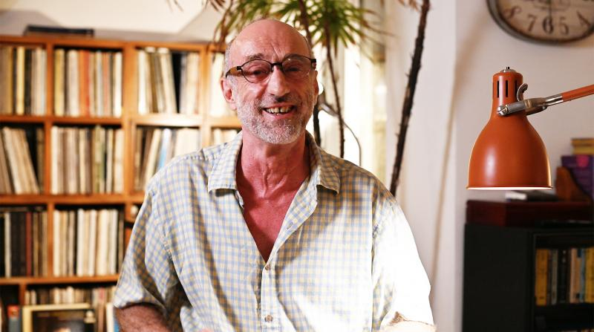

*Robin Munro stands in his studio last year in Taipei’s Yangmingshan. Photo: David Frazier*

“Robin helped many Chinese dissidents, who might otherwise have died in prison, to gain their freedom. I was one of them,” wrote Tiananmen democracy activist Han Dongfang (韓東方).

“His work on China human rights issues was hugely important,” tweeted Bloomberg reporter Benjamin Robertson.

**HUMAN RIGHTS ABUSES IN CHINA**

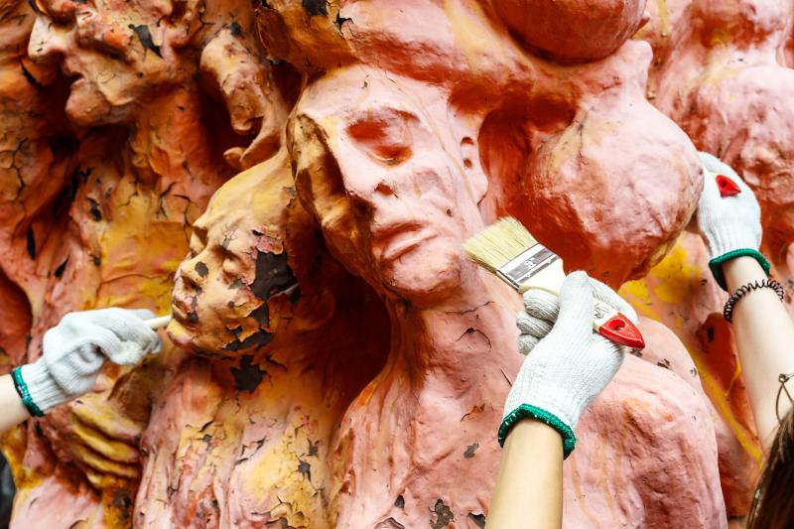

*Students clean the Pillar of Shame sculpture on June 4 at the University of Hong Kong, which commemorates China’s bloody crackdown on pro-democracy demonstrators in and around Beijing’s Tiananmen Square on June 4, 1989. Photo: Bloomberg*

Over the last three decades, Munro authored groundbreaking reports on China’s organ harvesting, abuses in orphanages, psychological torture of political prisoners and early rights abuses in Xinjiang.

Munro came into the human rights field when China was largely sealed off to the West and its human rights issues were little understood. He began his career in 1979 with Amnesty International in London, then in 1987 moved over to Human Rights Watch in New York. In early 1989, Human Rights Watch sent him to Hong Kong as its first dedicated China researcher and office director.

Within months of the posting to Hong Kong, student demonstrations erupted in Beijing’s Tiananmen Square, and Munro traveled north to witness them first hand. He is acknowledged as the last Western observer to leave the square early on the morning of June 4, 1989, staying on to witness the arrival of the People’s Liberation Army. Munro’s documentation of that event, and interviews he gave on Western TV news programs, became crucial to the world’s understanding of what was happening on the ground.

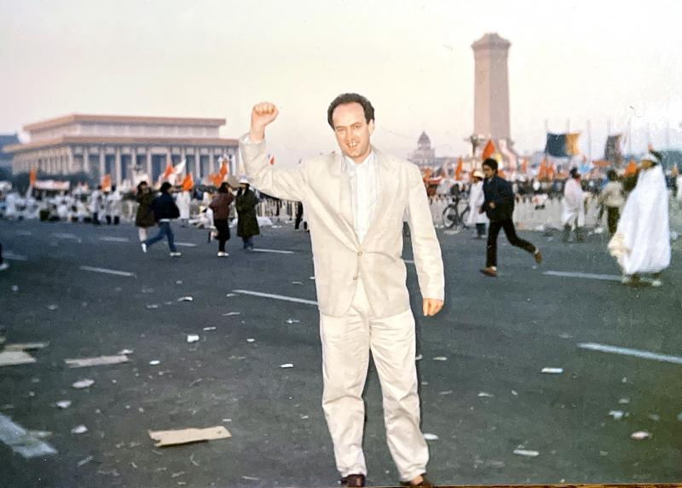

*Robin Munro raises his fist in June 1989, during student protests in Beijing’s Tiananmen Square. Photo courtesy of Huang Pao-lien*

A recent obituary from SOAS observed that Munro’s “account made the important point that it was not in fact students who were massacred in the Square, but rather the citizens of Beijing — the laobaixing (老百姓) — who were supporting the students in the streets outside the Square and were slaughtered there.”

In 1990, on Tiananmen’s first anniversary, Munro explained in an article in the US magazine The Nation, “A massacre did take place — but not in Tiananmen Square, and not predominantly of students. The great majority of those who died… were workers, or laobaixing (“common folk” or “old hundred names”), and they died mainly on the approach roads in western Beijing.”

Later in the article he explained that the reason these common citizens were “mercilessly punished [was] in order to eradicate organized popular unrest for a generation.”



*In this June 5, 1989 file photo, a man stands alone to block a line of tanks heading east on Beijing’s Cangan Boulevard in Tiananmen Square. Photo: AP*

“Journalism may be only the rough draft of history,” wrote Munro, “but if left uncorrected it can forever distort the future course of events.”

“I think that a key part of Robin’s success as an activist was his sense of responsibility, as a scholar, to the truth as supported by evidence. Despite his passion... he never exaggerated,” observed Donald Clarke, a specialist in Chinese law at George Washington University and one of Munro’s closest personal friends.

**MAN OF THE PEOPLE**

Robin Munro was born in London on June 1, 1952. At the age of six, he moved with his family to Scotland, where his father was a lecturer at the Veterinary School of Glasgow University.

His mother’s line included three generations of missionaries in China, going back to the 1800s. His own mother was born in 1918 in Swatow, China — present day Shantou, Guangdong Province — but as political upheaval swept China in the 1920s, the family returned to Edinburgh in 1925.

Munro began his studies at Edinburgh University in 1969, but dropped out for some time to live in a hippie commune on the Balearic island of Formentera, just next to Ibiza. In Scotland, he also drove a public bus, an item he kept on his CV for years as a nod to his labor credentials. When he returned to school in 1974, he changed his academic tack and began studying Chinese.

He traveled to China for the first time as a visiting student from 1977 to 1979, a period which perfectly straddled the end of the Cultural Revolution. In his first year at Peking University, his classmates and roommates were workers, peasants and soldiers assigned to the university by the Communist Party, while in his second year he studied with intellectuals returning from rural communes, who had been sent down by Chairman Mao Zedong (毛澤東).

In the decade following the Tiananmen massacre, Munro helped numerous fleeing Chinese dissidents attain asylum in the West.

He also “did pathbreaking research” — published as reports and books — “on China’s psychiatric abuse of political prisoners, abuses in orphanages and organ harvesting of convicts. He also broke new ground reporting on Inner Mongolia, the laogai (勞改, “reform through labor”) detention system in Xinjiang and repression of Catholics in Hebei province,” according to a statement by Human Rights Watch.

“All of these works constituted the first serious and scholarly examination of the problems they addressed,” wrote Clarke.

One of the Chinese dissidents Munro helped, Li Jinjin (李進進), tweeted, “It shocked me, the sad news that my friend Robin [is] gone. He met me after I was released from Qincheng Jail in Beijing in…1991. He helped me come to the United States in…1993.”

**PLIGHT OF ACTIVISTS**

Munro chronicled the plight of Li and other activists in the 1993 book Black Hands of Beijing, which he co-authored with George Black.

Another dissident assisted by Munro was one of the founders of the Beijing Workers’ Autonomous Federation, the aforementioned Han Dongfeng, whom Munro became friends with through frequent visits to the workers encampment in Tiananmen Square.

Following the 1989 crackdown, Han was imprisoned for two years and placed in a cell with tuberculosis sufferers. Han eventually lost a lung to the disease and might have died had Munro not lobbied for his release and helped arrange medical treatment.

In 1994, Han had settled in Hong Kong and there founded an NGO, China Labor Bulletin advocating for labor rights in China. Munro began working with him at the organization a decade later in 2003.

“Robin worked tirelessly over the past two decades to provide legal assistance for tens of thousands of Chinese workers seeking justice through the court system,” Han wrote in a recent tribute.

“Many of them had suffered terrible work injuries, contracted occupational diseases or were desperate to get the back pay owed for months, even years, of hard labor. Many workers faced imprisonment for defending their legal rights. These workers and their families should know that it was this Scotsman, Robin Munro, who helped them obtain justice.”

In 2004, Munro married the Taiwanese writer Huang Pao-lien (黃寶蓮), today a well-known author of 16 books of fiction and non-fiction.

**PERSONAL CONNECTION**

In 2011, the couple moved from Hong Kong to Taipei, after Munro was set upon by medical issues. For a decade, he managed to beat his illness, living happily in semi-retirement on the slopes of Yangmingshan, north of Taipei.

I met him there last year, where he helped me make a digital recording of old analogue audio tape, using one of his vintage reel-to-reel tape players.

Munro was a high-end audiophile, who spoke gleefully of his German hand-crafted turntable arm, his 1950s French amplifier and his unbelievable music collection, which included some of the first ever stereo recordings on analogue tape. I now regret that I never had the chance to return so that he could play them for me — he had of course made the generous offer, and spoke with vast and marvelous knowledge on the nuances of high fidelity.

Munro was taken by a sudden illness in April and died on May 19 at Taipei Veterans Memorial Hospital. He is survived by his sister Sandra and wife Huang Pao-lien, who was by his side to the last.

Munro influenced an entire generation of human rights workers in Asia, and recent numerous tributes acknowledge this legacy.

Their sentiments are best summed up in the eulogy of his longtime friend, Donald Clarke: “For many in the human rights community, his passing marks the loss of a giant figure. For his wife, sister and friends, it marks the loss of a part of themselves. For everyone, his life is a reminder of what matters in this world. In Shakespeare’s words, ‘His life was gentle, and the elements mixed so well in him that Nature might stand up and say to all the world, This was a man.’”